**MULTIPLE RENAME**

What are the things you want to do when you are intimate thoroughly with the flow and working of a programming language? Possibly many things.

Yes, we have come up with an idea to simplify more tedious tasks of regular life with few simple line of coding.

The first one on our bucket list is MULTIPLE RENAME.

Viability of a code or project seems apt only when it shows enough efficacy.

The notion behind this was to facilitate the folks, who finds it quite arduous to keep changing the names of all the files together in a folder.

For instance, you have 60 files/ images in your folder, and you address a situation where there is irregularity in the names and you have desire to change it. You will squander both time and energy if you think of changing it one by one.

As a consequence, this piece of code will help you to change the names instantly and simultaneously without any vaguely efforts.



The most basic and fledgling step that we must go through while beginning a program is import our modules or in other terms “header files”.

Since here, we are concerned with Python programming only, we intend to use the word module itself.

To begin with this program we must import the os module.

Let me just brief you about what this module basically does.

The os module allows you to use the operating system dependent functionality.

These functionalities allows you to interface with the particular hidden operating system in which you are currently running your python script.

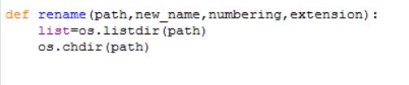

Subsequently, we must define a proper function. The functions in python are defined in such manner

def function_name(parameters) :

Here, we are passing the following parameters or arguments,

1. path- The path containing the files.

2. new_name- This will take the value of a string or name into which you intend to rename the files into.

3. numbering- This basically defines a start point of the renaming portion.

For instance, you want that all the files must be named as “Image1.jpg”,”Image2.jpg”, and such, then the numbering takes the value as ”1”

4. extension – This being imperative, you must mention appropriate extension such as “jpg” ,”png” , “mp4” etc.

Next, we are fetching the files using the functionality of os module, i.e os.listdir(path) and storing the same in a list.

Now, coming to os.chdir(path), it might strike to some folks that, is there any need to add this functionality? Yes, indeed there is.

os.listdir is only concerned with fetching the files, it is not leading to the directory. We will need to change the current directory with the path name mentioned, hence the need of os.chdir().

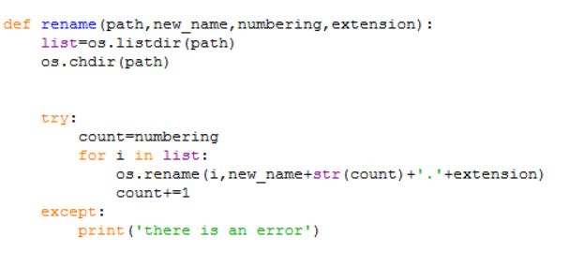

During creation of program, every programmer must make sure that his/her code must be able to handle run time errors.

To ensure that, we have included the exception handling concept of python.

In the try block, we are storing the user entered value of numbering into a variable named count.

Following that, we must define a business logic on how to renaming each file simultaneously. The intrinsic conscience lands to looping.

Hence, we are traversing each file in the list and renaming each one distinctly.

Following which, we are using an os functionality called rename.

The particular function has arguments, rename(old, new)

i: contains the old file name

The new file name:

new_name+str(count): we are converting the count into string, because it is not possible to concatenate string and integer.

extension: It is the extension of the file name

For instance, image.jpg gets converted to img1.png, img2.png and so on.

And every time an individual file has been renamed, the counter is incremented by one.

The except block handles run time errors, and as soon as it encounters any glitch or set-back, it will prompt the user that there is an error due to which it is not able to show any output.

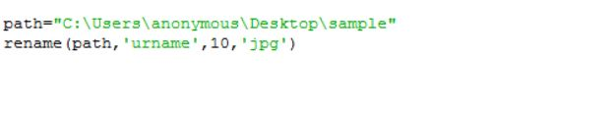

We have explicitly defined our path name, and then used the function we earlier defined called rename with appropriate arguments.

The rename function is changing the name to ‘urname’ and numbering starts from 10 with extension ‘jpg’.

The snapshots of the folder containing the files, before and after execution.

Before execution:



After execution:



Occasionally, you might not wish for specifying some of the arguments, for instance if you do not plan to change the extension for the file, you must not be compelled to specify any.

Hence, likewise there are many more such conditions which needs to be satisfied. Nevertheless, this small piece of code will work the same for your limited requisite.

For further comprehensive code replete with all the conditions and various error handling tactics, do visit our GitHub organization website.

The zip file for the code:

Do check out the video for the same -> video link

Thank you for your support, we foresee your feedbacks.

Follow us on Github -> link

Youtube->channel link

Facebook-> link